AI Fake Images Detection

- Some common hidden details for identifying AI fake images:
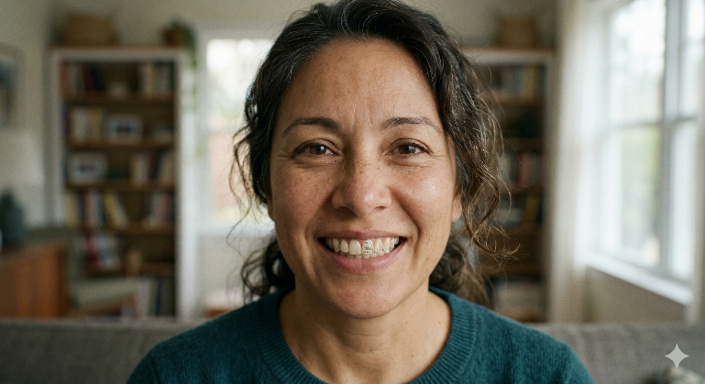
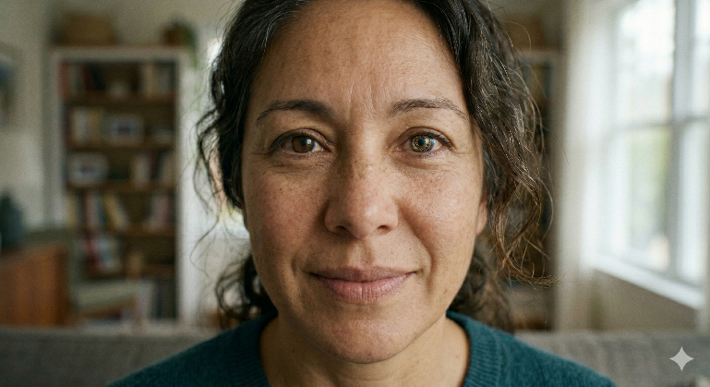

Uniform Eyes
Uniform Teeth
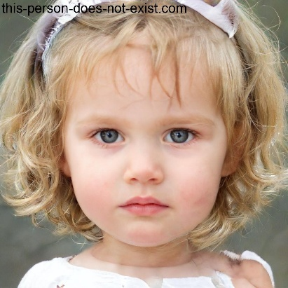
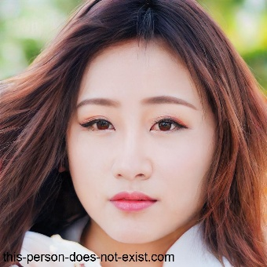

Perfect or Plastic Skin
Distortions

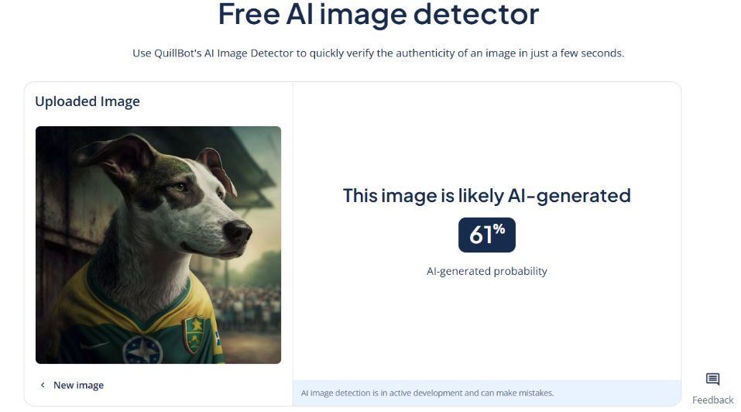
- AI tools for detecting AI fake images:

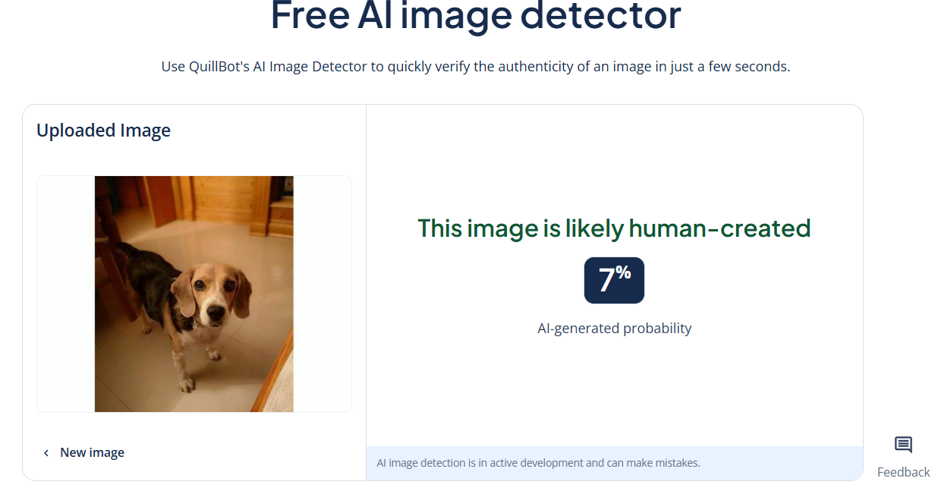

How do those AI tools work for detecting?: They are trained specifically for detecting hidden details like distortions, uniform things, stranger things, textures, etc.

- Vae’s architecture is one of the common AI model that is used for generating fake images:
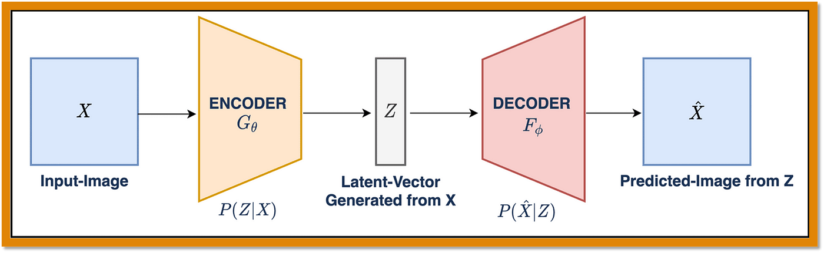
It allows generate new people or animals that they never existed because it encode and decode in new sintetyc data. It means that the ai model learned deep patterns encoding the input data and can to generate new data decoding
GAN and Transformes are anothers AI models can make this too

AI Ethical
- Ethically these AI generations have limitations and privations, avoiding have problems with the users personal data, deceiving social media with fake news or another incorrect use. For that reason the government is usually taking strict measures for regulating the power of the AI

